
FACULTY OF TECHNOLOGY
Department of AI, ML & DS
01AI0506 | DAA Lab Manual
 | Practical: 3 | Implementation of max-heap sort algorithm.
 | 11/08/2026
Aim: To Implement of max-heap sort algorithms.

MAX-H EAP SORT :

Algorithm:
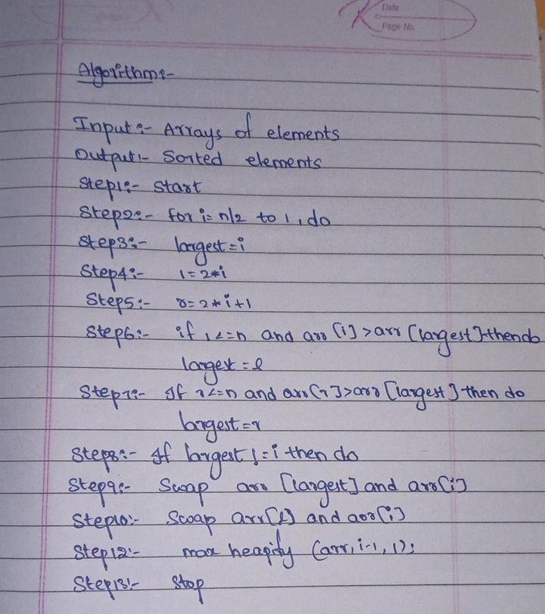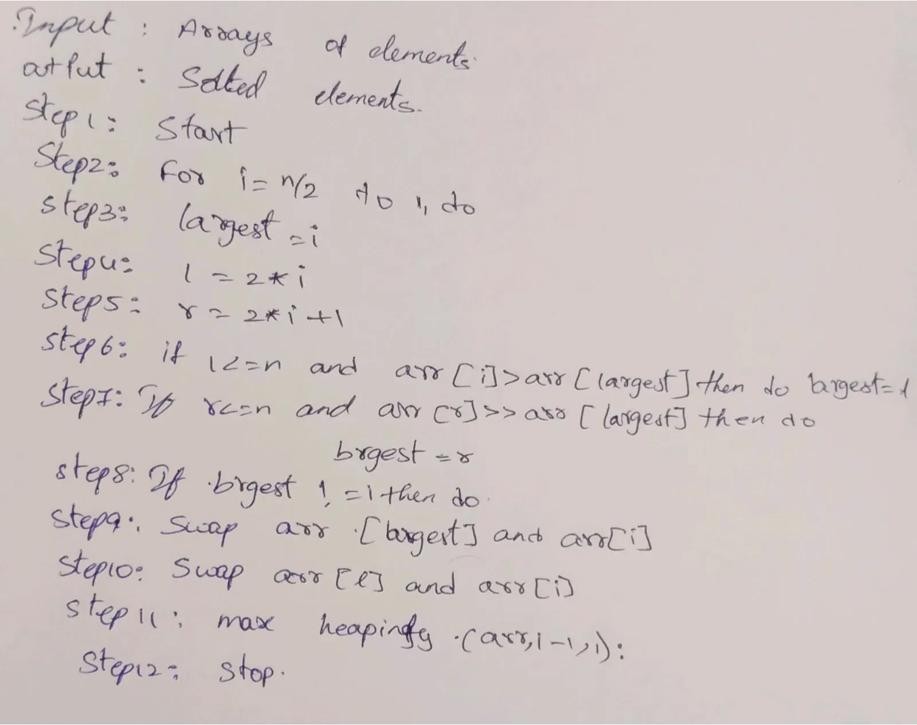

Program:


Yaswanth Sai (92400118993)
M.Lohith(92400118227)
Page No: 1

#include <iostream> using namespace std;
void heapify(int arr[], int n, int i) { int largest = i;
int left = 2 * i + 1; int right = 2 * i + 2;
if (left < n && arr[left] > arr[largest]) { largest = left;
} if (right < n && arr[right] > arr[largest]) { largest = right;
} if (largest != i) { swap(arr[i], arr[largest]); heapify(arr, n, largest);
}
} void heapSort(int arr[], int n) { for (int i = n / 2 - 1; i >= 0; i--) { heapify(arr, n, i);
} for (int i = n - 1; i > 0; i--) { swap(arr[0], arr[i]); heapify(arr, i, 0);
}
} int main() { int arr[] =
{4, 10, 3, 5, 1}; int n = 5;
heapSort(arr, n); for (int i
= 0; i < n; i++) { cout
<< arr[i] << " ";
}
return 0;
}

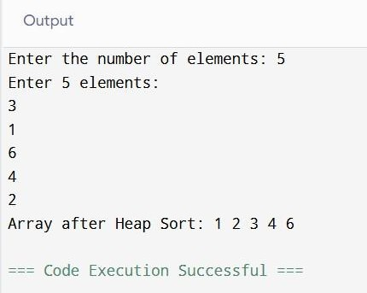
Output:



Yaswanth Sai (92400118993)
M.Lohith(92400118227)
Page No: 2

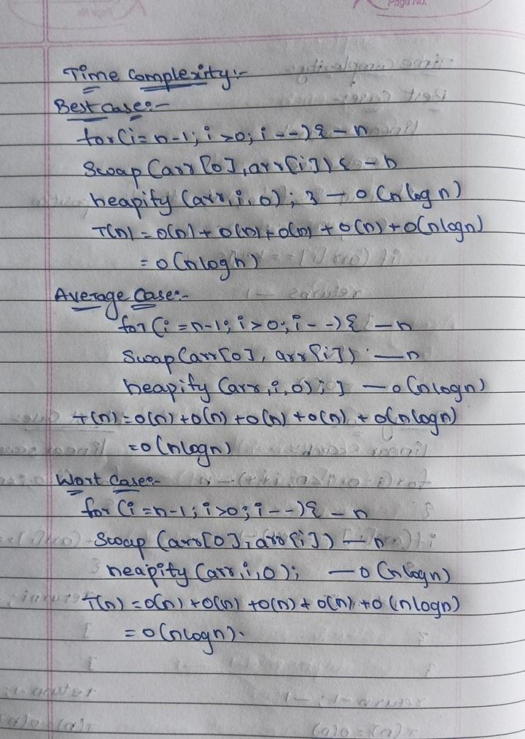
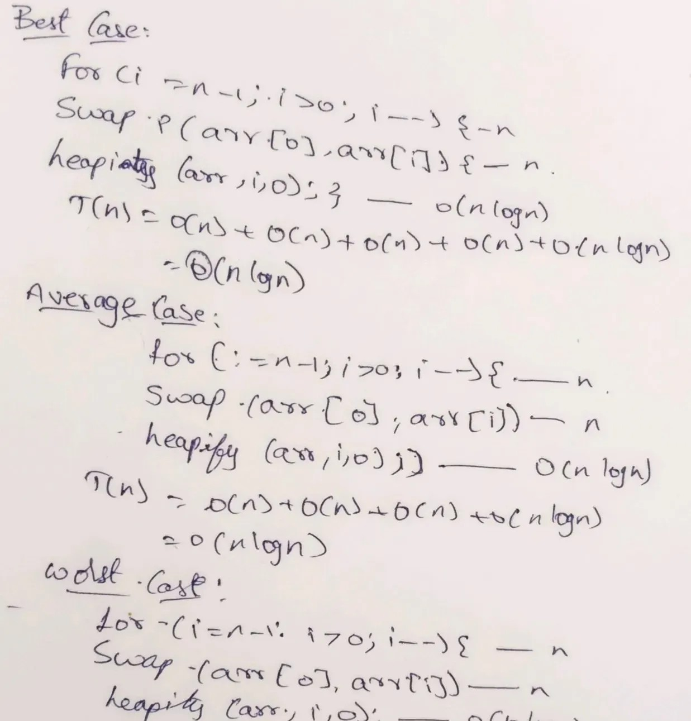
Time Complexity:

Conclusion:
The implementation and time analysis of Max-Heap Sort helps us understand its sortingefficiency. Max-Heap Sort builds a Max Heap and repeatedly swaps the maximum element withthe last element to sort the array in ascending order. It has a time complexity of O(n log n) in thebest, average, and worst cases.
Therefore, Max-Heap Sort is an efficient and consistent sortingalgorithm for handling large datasets.



Yaswanth Sai (92400118993)
M.Lohith(92400118227)
Page No: 3

